Matheus Ferreira
BSEE USF Student

Retro Gaming System Project Documentation
In this project I worked alongside Zachary Winningham to implement python-based retro games onto a handheld console. Each of us is developing our own game, but we are sharing the hardware. We chose to use a hardware kit called Retroflag GPi CASE 2W alongside the Raspberry Pi Zero 2W. We are using the pygame python package to assist in the game development process.
Zachary and I initially met up to plan which hardware we would use and to schedule a timeline for when we would work on finalizing our games and our hardware implementation, as well as adding Bluetooth features and getting a unified UI to work.

Developing my game: Little_Dude
I find the pseudo code is great for establishing a baseline for what a group’s goal is in developing a large software project, where each team member works on a given part of the software. However, with an independent project, I have a good idea of what I want to develop, and I might instead write notes on ideas for any problem I might encounter. Luckily pygame makes game development a bit of a no brainer, so I didn’t even have to write down extensive notes. I just made sure to comment on my source code well and occasionally needed some scratch paper to help out visualizing certain elements on the screen. So, I hit the ground running right away and just started developing my game.
To assist in version control and being able to access my code through a repository, I used GitHub desktop to begin development. Additionally, I used VSCode, with AI inline suggestions, and frequently used Gemini to help me with figuring out various functions within pygame.

Setting up on PC
- Download the .zip file on the Little_Dude github page.
- Extract the .zip file.
- Double click the install.bat file and run the install process.
- Double click the launch.bat file to launch the game.

Setting up on handheld

Hardware Requirements
- GPI CASE 2W
- Raspberry Pi Zero 2W
- microSD card

Software Requirements:
- PuTTY for SSH communication with device
https://www.chiark.greenend.org.uk/~sgtatham/putty/latest.html
- Little_Dude game local copy files
https://github.com/mrferreira-net/Little_Dude
source.py
/Data/
launch.sh
- Raspberry PI imager
https://downloads.raspberrypi.org/imager/imager_latest.exe
- Display patch
https://github.com/RetroFlag/GPICASE2W-display-patch
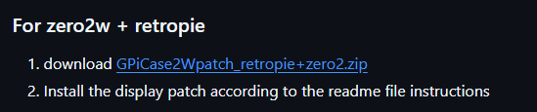

- Terminal command for safe shutdown
Save this command to be used later in the setup process
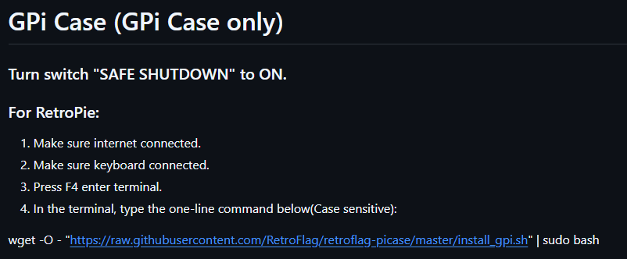
wget -O - "https://raw.githubusercontent.com/RetroFlag/retroflag-picase/master/install_gpi.sh" | sudo bash
- wpa_supplicant.conf
Can be made by saving .txt file as .conf:
country=US
ctrl_interface=DIR=/var/run/wpa_supplicant GROUP=netdev
update_config=1

# RETROPIE CONFIG START
network={
ssid=""
psk=""
}
# RETROPIE CONFIG END

Setup Instructions
- Turn on Retroflag.

- In RetroPie config menu, turn on SSH in interface options?

- On PuTTY SSH connect to IP address seen on retropie config menu

- Run the follow command for safe shutdown in terminal window:
wget -O - "https://raw.githubusercontent.com/RetroFlag/retroflag-picase/master/install_gpi.sh" | sudo bash

- Shut down retropie in menu. Flip safe shutdown switch on the back of the Retroflag.

- Turn on Retroflag

- Install all RetroPie setup updates – may need to run update install multiple times and reboot, ensure everything gets installed with no error messages at the end of install. may need to remove SD card and uninstall then reinstall patch if audio breaks after you completely install all updates.

- On PuTTY SSH:
sudo apt install python3-pip
sudo apt install python3-numpy
python3 -m pip install pygame-ce

- install optional port (sets up ports directory properly)
Retropie setup > Manage Packages > opt packages > ports

- On your computer you can open the RetroPie directory by accessing via the RetroPie’s IP //[IP ADRESS]
Place game directory in /home/pi/RetroPie/roms/ports/

- Add joystick initialization to game sourcecode

- Examples of modifying game controls for joystick control in main game loop:
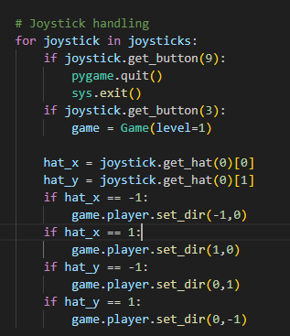
Example 1

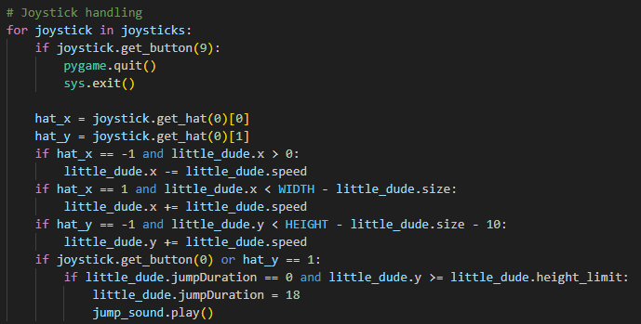
Example 2

- Create .sh file to launch your game with the following command:
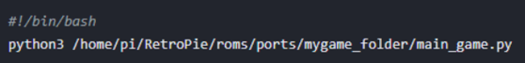

- Mount your .sh to be launchable from ports menu on RetroPie:

Bluetooth file transfer
Open PuTTY SSH terminals for both devices
Have SENDER device with source file ready.

On both SSH terminals run these commands:
sudo apt install obexpushd obexftp bluez-obexd
bluetoothctl
power on
discoverable on
pair [MAC_ADDRESS of other Pi]
trust [MAC_ADDRESS of other Pi]
exit

On receiver run the command below:
obexpushd -B23 -o [LOCATION FOR FILES TO BE RECEIVED] -n

my current receive directory:
/home/pi/RetroPie/roms/ports/Shared

On sender run the command below:
obexftp -b [MAC ADDRESS of receiver] --channel 23 -p [LOCATION OF SOURCE FILE]

my current source file directory:
/home/pi/RetroPie/roms/ports/Shared/test.txt

